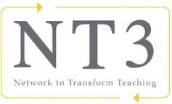
Five Core Propositions Jigsaw
Use this handout to take notes during the What Teachers Should Know and Be Able to Do book jigsaw presentations.

Propositions | Notes
Proposition 1: Teachers are committed to students and their learning.

Proposition 2: Teachers know the subjects they teach and how to teach those subjects to students.

Proposition 3: Teachers are responsible for managing and monitoring student learning.

Proposition 4: Teachers think systematically about their practice and learn from experience.

Proposition 5: Teachers are members of learning communities.

